Daniel Prusinski

Predict 412

Programming Assignment 5: Mathematical Programming

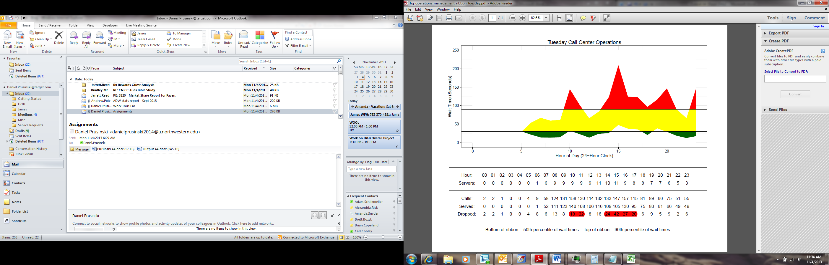 Earlier this year, I worked for US Bank in the Fraud Analytics Department (FAD). Within the FAD, there was a call center unit with over 300 employees. Management viewed any customer waiting more than 30 seconds as unacceptable, and yearly bonuses were attached to call times. While there were many factors that contributed to customers waiting such as number of current fraud cases open and fraud trends, the greatest factor was call center employees. Optimizing the number of call center employees working with customer calls was a major challenge and mathematical programming offers a unique approach to finding a balance.

The following exploratory data analysis (EDA) employs mathematical programming methods on finding the optimum call center staff on Tuesdays for “Anonymous Bank” in Israel. Multiple data sets for this EDA include a set containing the call log for February 1999, 33,344 unique observations, and a corresponding customer service shifts dataset that contains 24 unique observations with 10 variables. All outputs, graphs, and visualizations are found within Appendix 1. The graph below shows the hours and wait times, notice the four major spikes where customers are waiting 150 plus seconds. Management establishes the wait time goals, and through mathematical programming the ideal graph would show little to no red and a thick, yellow, oscillating line to assuage customer spikes. One should note there are multiple approaches to solve this request.

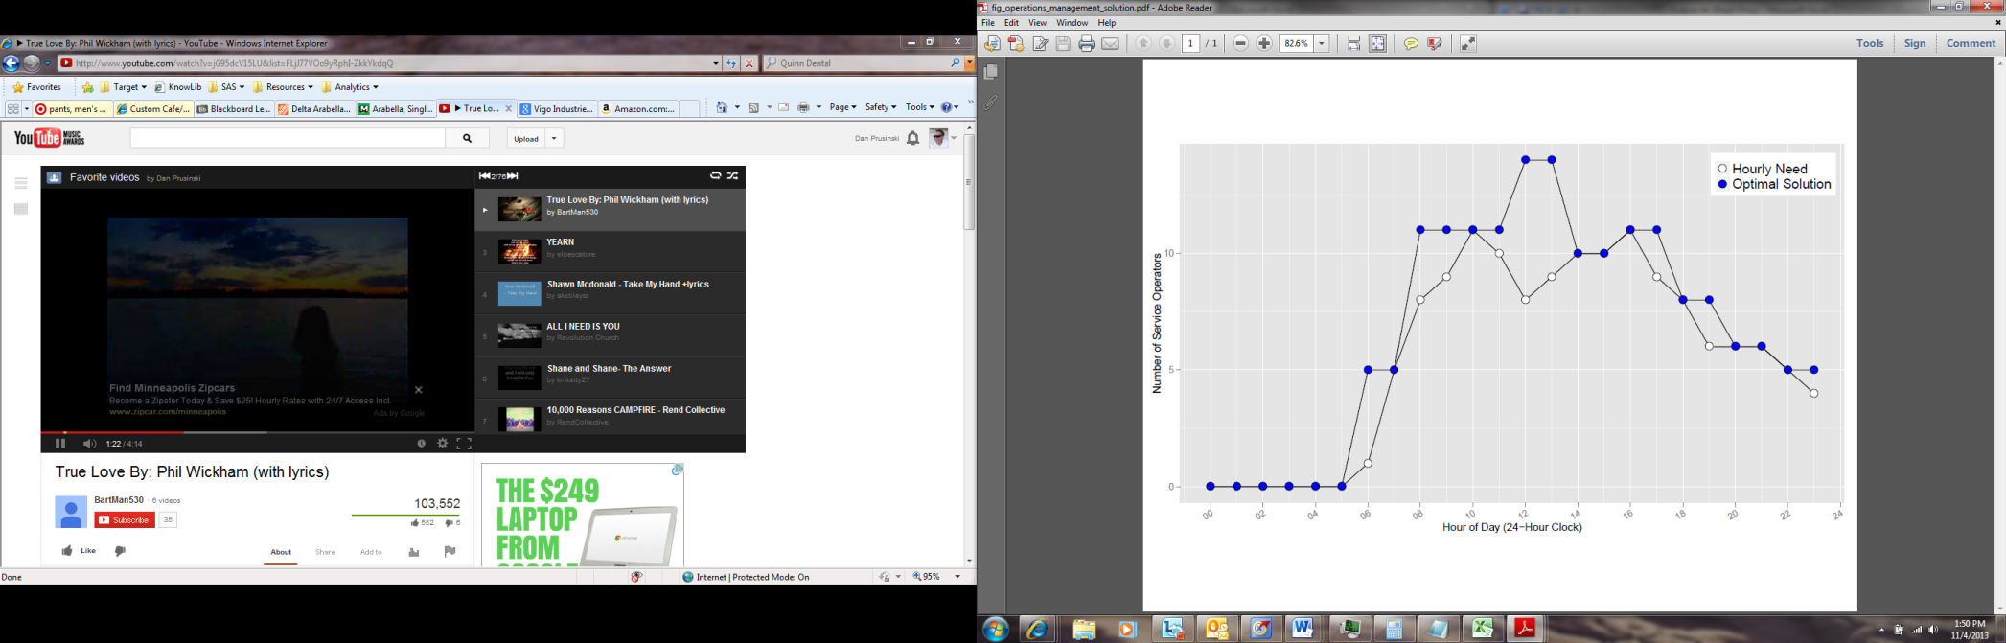 Mathematical programming sounds similar to computer programming, but the word “programming” is better explained as “planning” (Williams, 1999). Rather, computers are used to execute the arithmetic required from the “planning”. The mathematical program being built seeks to optimally minimize calls over 90 seconds while at the same time also minimizing the required customer service employees. Given that whole individuals are required, the problem is constrained optimization with an integer solution, thus integer programming is utilized (Miller, 2013). As seen in output 3, the spikes in customer wait time traverse later in the day at about five hour increments. Staggered shift start and end times along with the number of employees present are the variables available to assuage the long wait times. Assumptions for performance metrics follow the Erlang C model, which is 15 calls per hour. Output 4 visually shows how the current Tuesday shift is understaffed based on calls arriving versus being served. The greatest disparities occur around the 10th and 15th hour marks, but the overall trend shows that fewer customers are being served than those that have arrived.

Based on the inputs, the graph below shows the optimum solution for Tuesdays at the “Anonymous Bank” in Israel, which is 6,264 Ills (Output 5). Notice how hourly need lags under the optimal solution, this is best explained as taking into consideration longer calls. To make this process more robust one could do testing utilizing Poisson process through discrete event simulation and iterate through multiple trials for an optimal fit.

Works Cited

Miller, Thomas W.. *Modeling Techniques In Predictive Analytics: Business Problems And Solutions With R*. New Jersey: Pearson Education, 2013. Print.

Williams , H. *Model Building in Mathematical Programmin*. 1978. Reprint. New York: John Wiley & Sons, 1999. Print.